

**AMERICAN INTERNATIONAL UNIVERSITY-BANGLADESH (AIUB)**

**INTRODUCTION TO DATABASE**

**FALL 2022-2023**

**Section: G Group: 05 ,**

PROJECT REPORT ON

**ORGAN BANK MANAGEMENT SYSTEM**

Supervised By

**Syed Nafiul Shefat**

**Submitted By:**

|  |  |
| --- | --- |
| **NAME** | **ID** |
| MD. SHOHANUR RAHMAN SHOHAN | 22-46013-1 |
| MAHMUDA KHATUN | 22-47016-1 |
| 1. F. M. RAFIUL HASSAN | 22-47048-1 |

**TABLE OF CONTENTS**

|  |  |
| --- | --- |
| TOPICS | Page no. |
| 1. Introduction | 3 |
| 1. Scenario Description | 3 |
| 1. Entity Relationship Diagram | 4 |
| 1. Normalization | 5-10 |
| 1. Total Table | 11 |
| 1. Finalization | 12 |
| 1. Constraints | 13-15 |
| 1. Table Creation | 16-19 |
| 1. Data Insertion | 20-23 |
| 1. Query Test | 24-27 |
| 1. Conclusion | 28 |

**INTRODUCTION**

The Organ Bank Management System is required for managing organ, designed for use by the Life Angel Organ Bank. The system is designed to connect with an extensive database of donor, organ, manager etc. details. These entities are organized the Organ Bank in hierarchal structure which can be traversed briefly, giving commanders a visual summary of statuses through an Oracle 10g Database system interface.

**Scenario Description**

An organ bank stores various types of organs. Many donors can donate different type of organ. A donor may donate organ more than once and he/she is identified by a donor id, name, age, gender, address, and phone number. The organ donated by the donor is distinguish by organ type, organ id, blood group and organ stored date. Before each donor donates his/her organ, he/she is required to register himself as a donor with the receptionist who works at the organ bank. The receptionist is characterized by receptionist id, name, address, and phone number. The organ banks receive orders for organ from many hospitals for emergency purposes and other surgical requirements and organ bank issues the same of required type of organ. The hospitals are identified by hospital id, name, address, organ issue date, orders, and phone number. Organ bank has organ bank id, name, address, and organ types stored. The organ bank is managed by the manager who is identified by manager id, name, e-mail id, address, and phone number. He/she is responsible for the proper management of the organ bank.

**Entity Relationship Diagram**

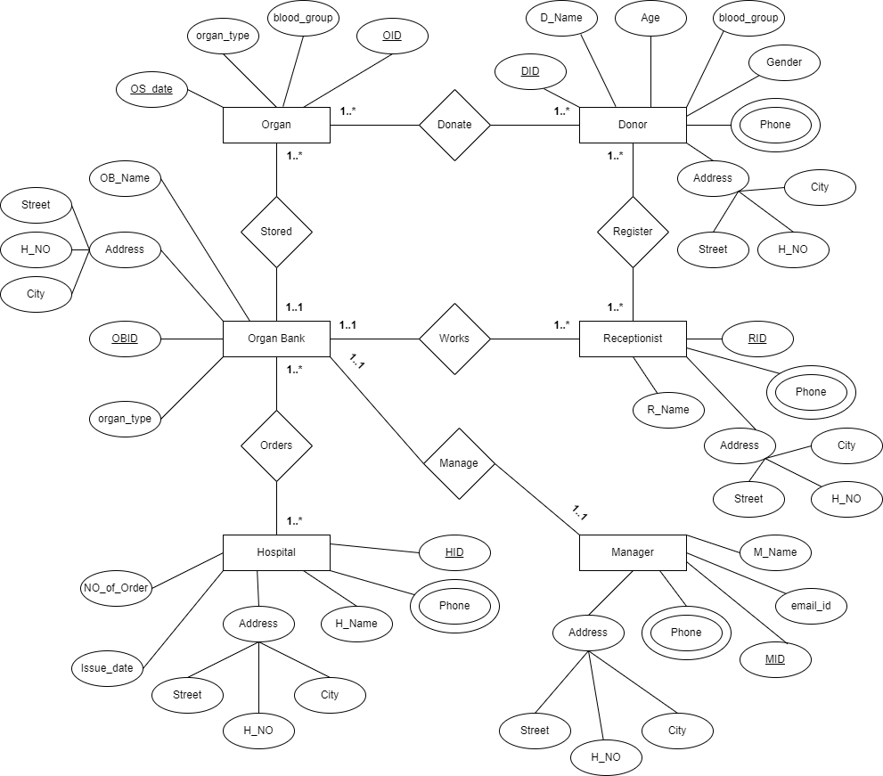

**NORMALIZATION**

**Donate:**

**UNF:**

DID, D_NAME, AGE, BLOOD_GROUP, GENDER, PHONE, H_NO, STREET, CITY, OID, BLOOD_GROUP, ORGAN_TYPE, OS_DATE

**1NF:** PHONE is a multivalued attribute.

DID, D_NAME, AGE, BLOOD_GROUP, GENDER, H_NO, STREET, CITY, OID, BLOOD_GROUP, ORGAN_TYPE, OS_DATE

**2NF:**

1. DID, D_NAME, AGE, BLOOD_GROUP, GENDER, H_NO, STREET, CITY, OID, PID
2. PHONE, PID
3. OID, BLOOD_GROUP, ORGAN_TYPE, OS_DATE

**3NF:**

1. DID, D_NAME, AGE, BLOOD_GROUP, GENDER, OID, PID, AID
2. PID, PHONE
3. AID, H_NO, STREET, CITY
4. OID, BLOOD_GROUP, ORGAN_TYPE, OS_DATE

**Register:**

**UNF:**

DID, D_NAME, AGE, BLOOD_GROUP, GENDER, PHONE, H_NO, STREET, CITY, RID, R_NAME, PHONE, H_NO, STREET, CITY

**1NF:** PHONE is a multivalued attribute.

DID, D_NAME, AGE, BLOOD_GROUP, GENDER, H_NO, STREET, CITY, RID, R_NAME, PHONE, H_NO, STREET, CITY

**2NF:**

1. DID, D_NAME, AGE, BLOOD_GROUP, GENDER, H_NO, STREET, CITY, RID, PID
2. PID, PHONE
3. RID, R_NAME, H_NO, STREET, CITY, PID

**3NF:**

1. DID, D_NAME, AGE, BLOOD_GROUP, RID, PID, AID
2. PID, PHONE
3. AID, H_NO, STREET, CITY
4. RID, R_NAME, PID, AID

**Stored:**

**UNF:**

OID, BLOOD_GROUP, ORGAN_TYPE, OS_DATE, OBID, OB_NAME, ORGAN_TYPE, H_NO, STREET, CITY

**1NF:** **NO** multivalued attribute. (SAME AS **UNF**)

OID, BLOOD_GROUP, ORGAN_TYPE, OS_DATE, OBID, OB_NAME, ORGAN_TYPE, H_NO, STREET, CITY

**2NF:**

1. OID, BLOOD_GROUP, ORGAN_TYPE, OS_DATE, OBID
2. OBID, OB_NAME, ORGAN_TYPE, H_NO, STREET, CITY

**3NF:**

1. OID, BLOOD_GROUP, ORGAN_TYPE, OS_DATE, OBID
2. OBID, OB_NAME, ORGAN_TYPE, AID
3. AID, H_NO, STREET, CITY

**Works:**

**UNF:**

OBID, OB_NAME, ORGAN_TYPE, H_NO, STREET, CITY, RID, R_NAME, PHONE, H_NO, STREET, CITY

**1NF:** PHONE is a multivalued attribute.

OBID, OB_NAME, ORGAN_TYPE, H_NO, STREET, CITY, RID, R_NAME, H_NO, STREET, CITY

**2NF:**

1. OBID, OB_NAME, ORGAN_TYPE, H_NO, STREET, CITY
2. PID, PHONE
3. RID, R_NAME, PHONE, H_NO, STREET, CITY, OBID, PID

**3NF:**

1. OBID, OB_NAME, ORGAN_TYPE, AID
2. PID, PHONE
3. AID, H_NO, STREET, CITY
4. RID, R_NAME, OBID, PID, AID

**Orders:**

**UNF:**

OBID, OB_NAME, ORGAN_TYPE, H_NO, STREET, CITY, HID, H_NAME, PHONE, NO_OF_ORDER, ISSUE_DATE, H_NO, STREET, CITY

**1NF:** PHONE is a multivalued attribute.

OBID, OB_NAME, ORGAN_TYPE, H_NO, STREET, CITY, HID, H_NAME, NO_OF_ORDER, ISSUE_DATE, H_NO, STREET, CITY

**2NF:**

1. OBID, OB_NAME, ORGAN_TYPE, H_NO, STREET, CITY
2. PID, PHONE
3. HID, H_NAME, NO_OF_ORDER, ISSUE_DATE, H_NO, STREET, CITY, OBID, PID

**3NF:**

1. OBID, OB_NAME, ORGAN_TYPE, AID
2. PID, PHONE
3. AID, H_NO, STREET, CITY
4. HID, H_NAME, NO_OF_ORDER, ISSUE_DATE, OBID, PID, AID

**Manage:**

**UNF:**

OBID, OB_NAME, ORGAN_TYPE, H_NO, STREET, CITY, MID, M_NAME, EMAIL_ID, PHONE, H_NO, STREET, CITY

**1NF:** PHONE is a multivalued attribute.

OBID, OB_NAME, ORGAN_TYPE, H_NO, STREET, CITY, MID, M_NAME, EMAIL_ID, H_NO, STREET, CITY

**2NF:**

1. OBID, OB_NAME, ORGAN_TYPE, H_NO, STREET, CITY
2. PID, PHONE
3. MID, M_NAME, EMAIL_ID, H_NO, STREET, CITY, OBID, PID

**3NF:**

1. OBID, OB_NAME, ORGAN_TYPE, AID
2. PID, PHONE
3. AID, H_NO, STREET, CITY
4. MID, M_NAME, EMAIL_ID, OBID, PID, AID

**TOTAL TABLE**

1. DID, D_NAME, AGE, BLOOD_GROUP, GENDER, OID, PID, AID
2. PID, PHONE
3. AID, H_NO, STREET, CITY
4. OID, BLOOD_GROUP, ORGAN_TYPE, OS_DATE
5. DID, D_NAME, AGE, BLOOD_GROUP, RID, PID, AID
6. PID, PHONE
7. AID, H_NO, STREET, CITY
8. RID, R_NAME, PID, AID
9. OID, BLOOD_GROUP, ORGAN_TYPE, OS_DATE, OBID
10. OBID, OB_NAME, ORGAN_TYPE, AID
11. AID, H_NO, STREET, CITY
12. OBID, OB_NAME, ORGAN_TYPE, AID
13. PID, PHONE
14. AID, H_NO, STREET, CITY
15. RID, R_NAME, OBID, PID, AID
16. OBID, OB_NAME, ORGAN_TYPE, AID
17. PID, PHONE
18. AID, H_NO, STREET, CITY
19. HID, H_NAME, NO_OF_ORDER, ISSUE_DATE, OBID, PID, AID
20. OBID, OB_NAME, ORGAN_TYPE, AID
21. PID, PHONE
22. AID, H_NO, STREET, CITY
23. MID, M_NAME, EMAIL_ID, OBID, PID, AID

**FINALIZATION**

1. PID, PHONE

2. AID, H_NO, STREET, CITY

3. OBID, OB_NAME, AID

4. OID, BLOOD_GROUP, ORGAN_TYPE, OS_DATE, OBID

5. HID, H_NAME, NO_OF_ORDER, ISSUE_DATE, OBID, PID, AID

6. RID, R_NAME, OBID, PID, AID

7. DID, D_NAME, AGE, BLOOD_GROUP, GENDER, OID, PID, AID

8. MID, M_NAME, EMAIL_ID, OBID, PID, AID

**Constraints**

1. PHONE_NUMBER:

|  |  |  |
| --- | --- | --- |
| **Column Name** | **Data Type** | **Constraints** |
| PID | VARCHAR2(5) | PRIMARY KEY |
| PHONE | VARCHAR2(11) | NOT NULL |

1. ADDRESS:

|  |  |  |
| --- | --- | --- |
| **Column Name** | **Data Type** | **Constraints** |
| AID | VARCHAR2(5) | PRIMARY KEY |
| H_NO | NUMBER (4,0) | NOT NULL |
| STREET_NUMBER | NUMBER (3,0) | NOT NULL |
| CITY | VARCHAR2(255) | NOT NULL |

1. ORGAN_BANK:

|  |  |  |
| --- | --- | --- |
| **Column Name** | **Data Type** | **Constraints** |
| OBID | VARCHAR2(6) | PRIMARY KEY |
| OB_NAME | VARCHAR2(15) | NOT NULL |
| AID | VARCHAR2(5) | NOT NULL, FOREIGN KEY from “ADDRESS” |

1. ORGAN:

|  |  |  |
| --- | --- | --- |
| **Column Name** | **Data Type** | **Constraints** |
| OID | VARCHAR2(5) | PRIMARY KEY |
| BLOOD_GROUP | VARCHAR2(3) | CHECK, NOT NULL |
| ORGAN_TYPE | VARCHAR2(255) | NOT NULL |
| OS_DATE | DATE | NOT NULL |
| OBID | VARCHAR2(6) | NOT NULL, FOREIGN KEY from “ORGAN_BANK” |

1. HOSPITAL:

|  |  |  |
| --- | --- | --- |
| **Column Name** | **Data Type** | **Constraints** |
| HID | VARCHAR2(5) | PRIMARY KEY |
| H_NAME | VARCHAR2(255) | NOT NULL |
| NO_OF_ORDER | NUMBER (3) | NOT NULL |
| ISSUE_DATE | DATE | NOT NULL |
| OBID | VARCHAR2(6) | NOT NULL, FOREIGN KEY from “ORGAN_BANK” |
| PID | VARCHAR2(5) | NOT NULL, FOREIGN KEY from “PHONE_NUMBER” |
| AID | VARCHAR2(5) | NOT NULL, FOREIGN KEY from “ADDRESS” |

1. RECIPTIONIST:

|  |  |  |
| --- | --- | --- |
| **Column Name** | **Data Type** | **Constraints** |
| RID | VARCHAR2(5) | PRIMARY KEY |
| R_NAME | VARCHAR2(255) | NOT NULL |
| OBID | VARCHAR2(6) | NOT NULL, FOREIGN KEY from “ORGAN_BANK” |
| PID | VARCHAR2(5) | NOT NULL, FOREIGN KEY from “PHONE_NUMBER” |
| AID | VARCHAR2(5) | NOT NULL, FOREIGN KEY from “ADDRESS” |

1. DONOR

|  |  |  |
| --- | --- | --- |
| **Column Name** | **Data Type** | **Constraints** |
| DID | VARCHAR2(5) | PRIMARY KEY |
| D_NAME | VARCHAR2(255) | DEFAULT |
| AGE | NUMBER (3) | NOT NULL |
| BLOOD_GROUP | VARCHAR2(3) | CHECK, NOT NULL |
| GENDER | VARCHAR2(255) | CHECK, NOT NULL |
| OID | VARCHAR2(5) | NOT NULL, FOREIGN KEY from “ORGAN” |
| PID | VARCHAR2(5) | NOT NULL, FOREIGN KEY from “PHONE_NUMBER” |
| AID | VARCHAR2(5) | NOT NULL, FOREIGN KEY from “ADDRESS” |

1. MANAGER:

|  |  |  |
| --- | --- | --- |
| **Column Name** | **Data Type** | **Constraints** |
| MID | VARCHAR2(5) | PRIMARY KEY |
| M_NAME | VARCHAR2(255) | NOT NULL |
| EMAIL_ID | VARCHAR2(255) | NOT NULL |
| OBID | VARCHAR2(6) | NOT NULL, FOREIGN KEY from “ORGAN_BANK” |
| PID | VARCHAR2(5) | NOT NULL, FOREIGN KEY from “PHONE_NUMBER” |
| AID | VARCHAR2(5) | NOT NULL, FOREIGN KEY from “ADDRESS” |

**TABLE CREATION**

1. PHONE_NUMBER:

1. ADDRESS:

1. ORGAN_BANK:

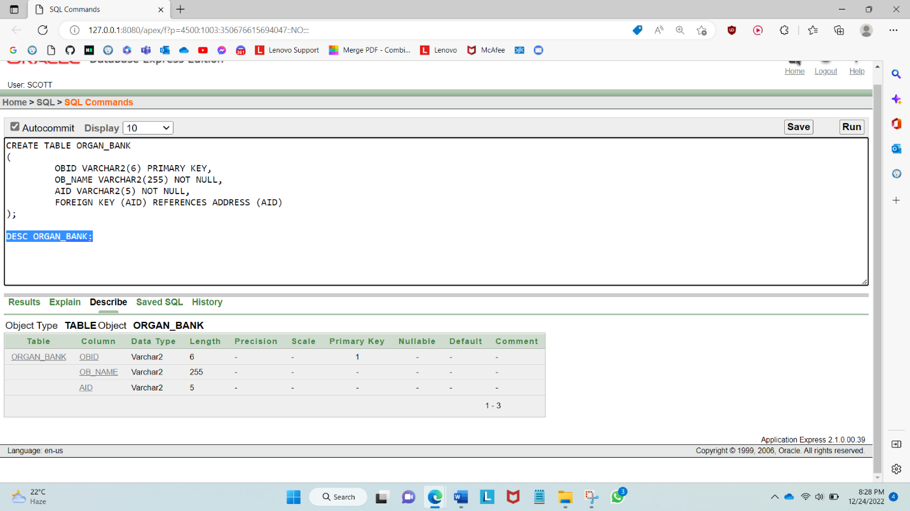

1. ORGAN:

1. HOSPITAL:

1. RECIPTIONIST:

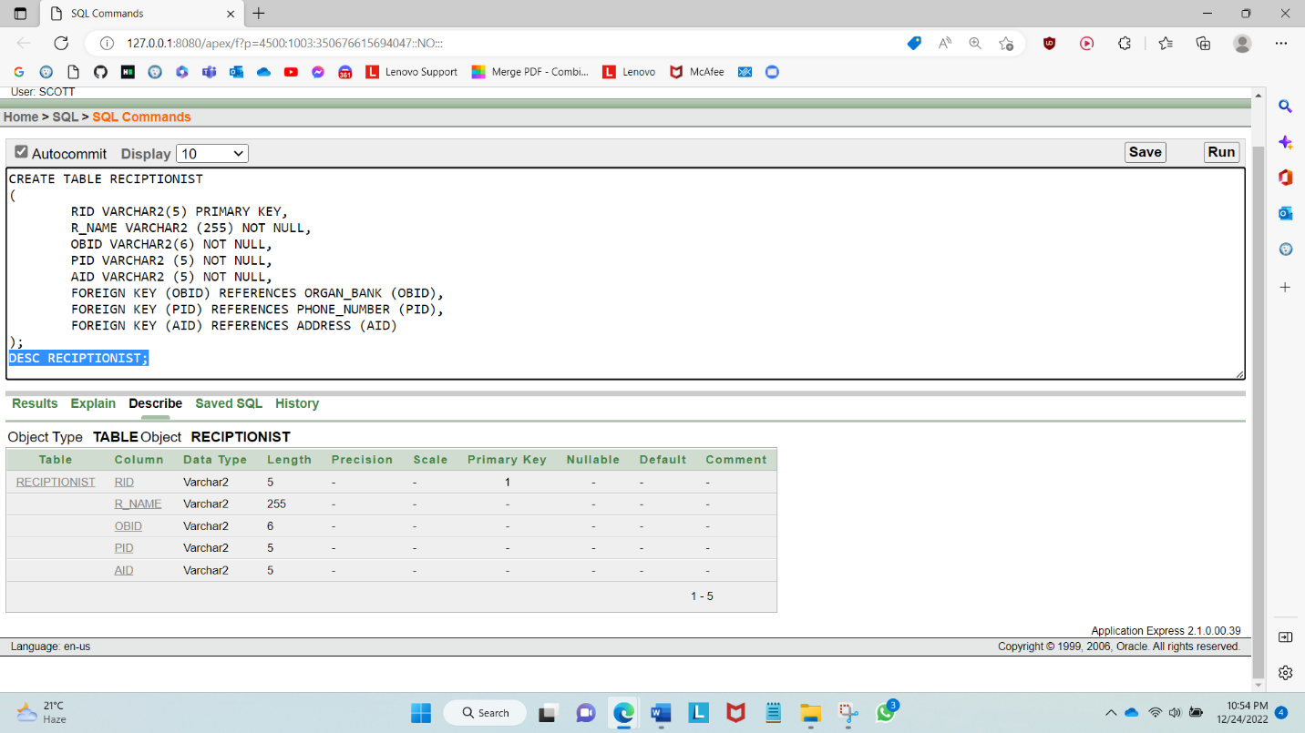

1. DONOR:

1. MANAGER:

**DATA INSERTION**

1. PHONE_NUMBER:

1. ADDRESS:

1. ORGAN_BANK:

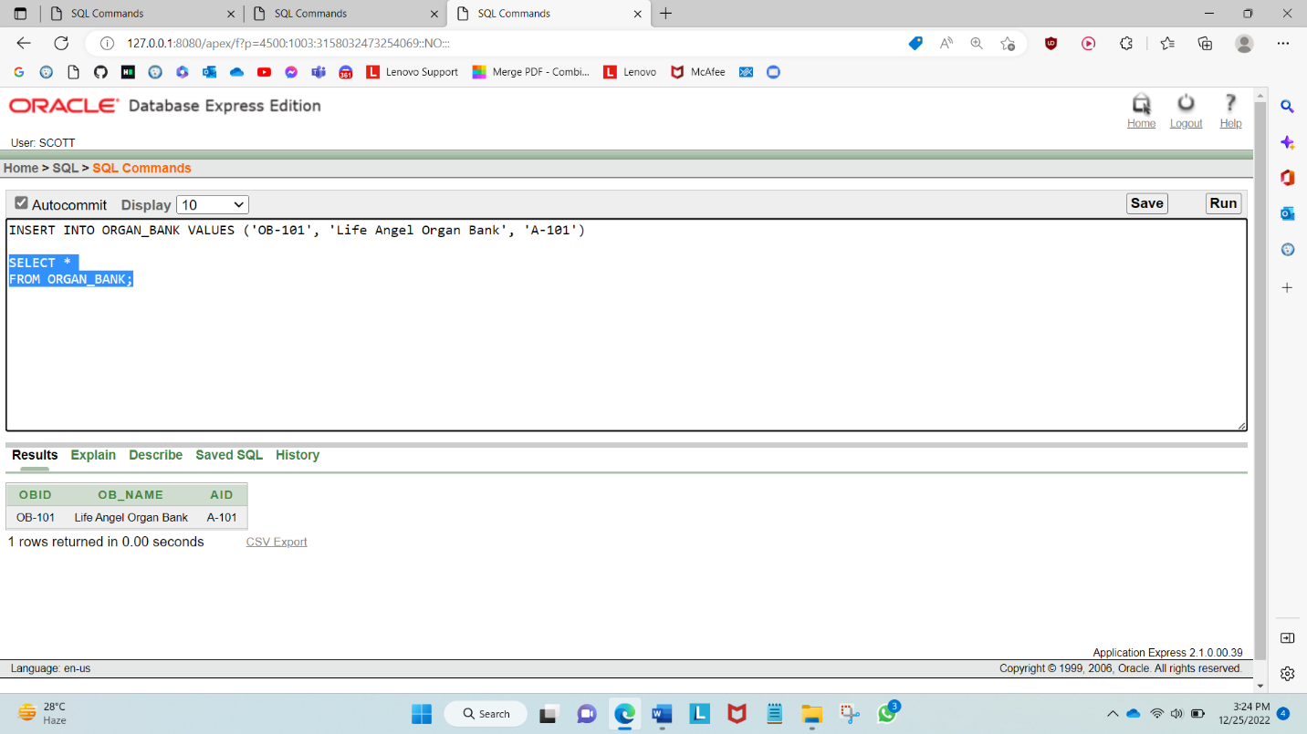

1. ORGAN:

1. HOSPITAL:

1. RECIPTIONIST:

1. DONOR:

1. MANAGER:

**QUERY TEST**

Basic Query

1. Show the address info whose location (city) in CHOTTAGRAM.

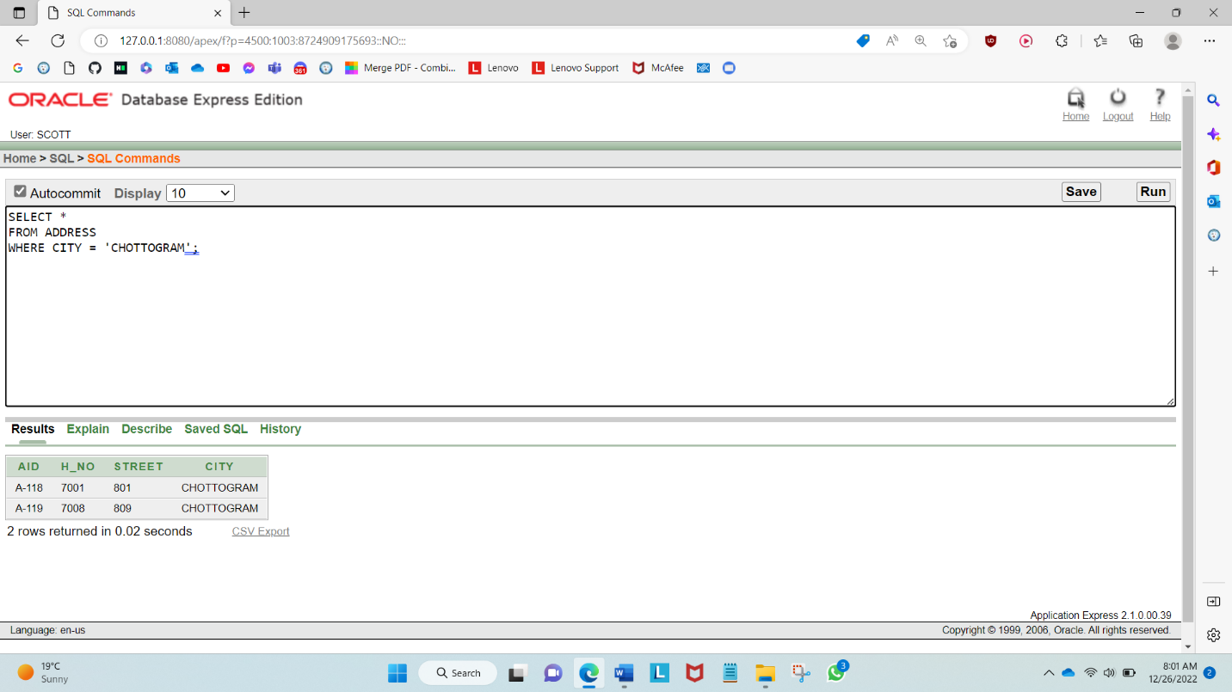

1. Show organ id, organ type, organ stored date where heart doesn’t exist

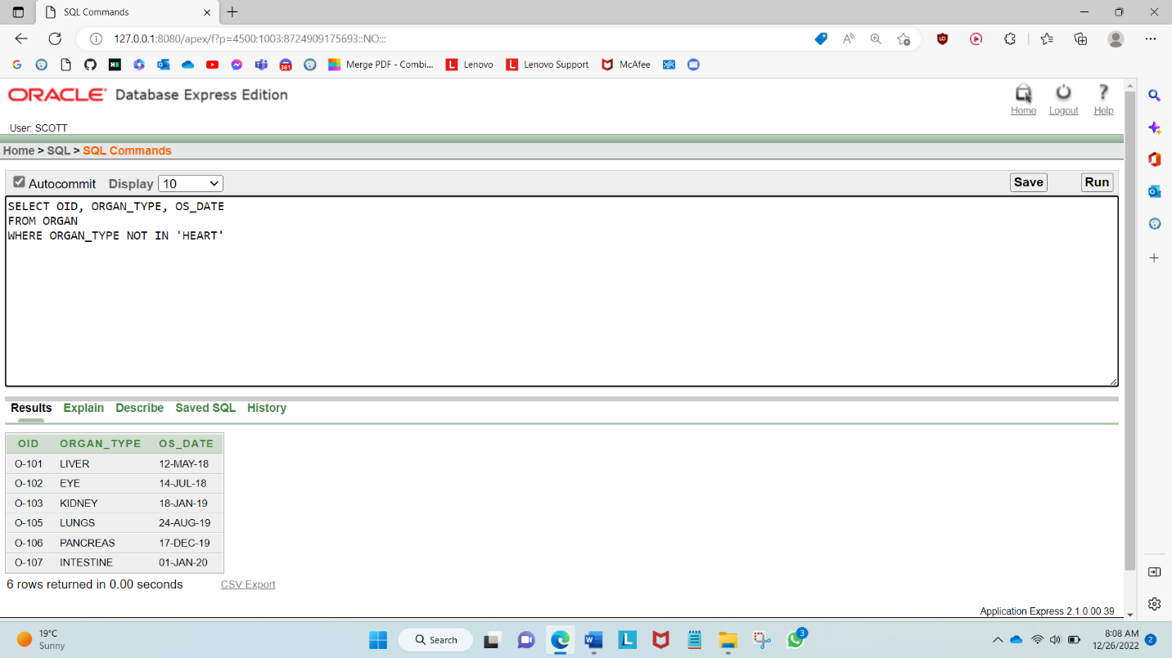

Sub Query

1. Display the donor id, age, blood group, gender whose age is greater than donor id = D-106

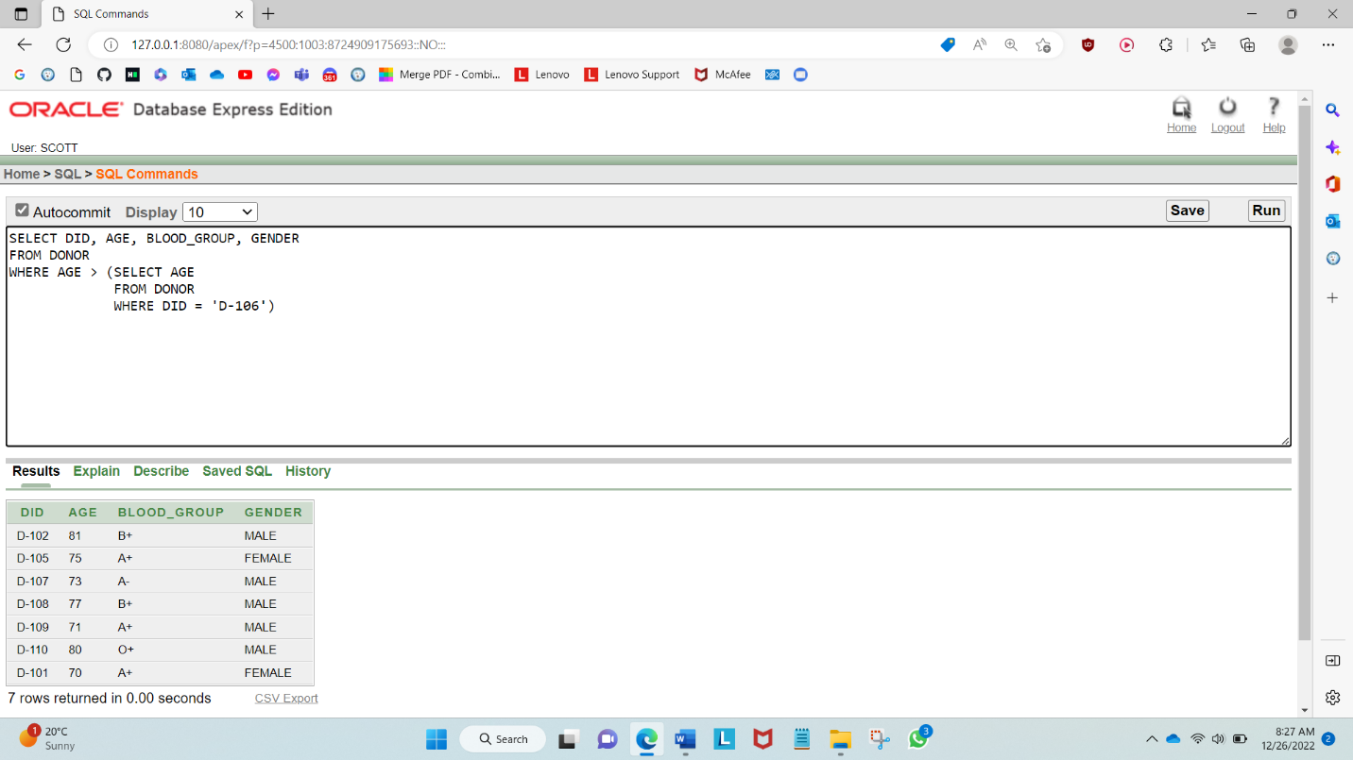

1. Display organ id, organ type and age whose age is between 50 to 65

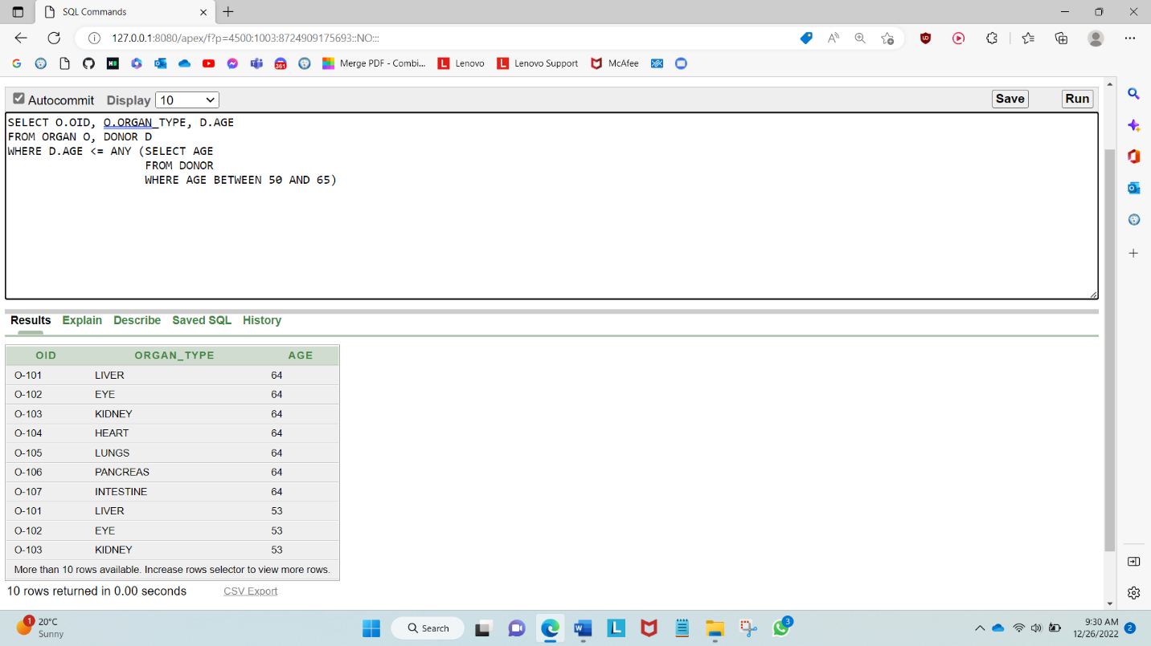

Joining

1. Show the donor id, donor name, donor age those are from the city RAJSHAHI

1. Show organ bank name, hospital name, issue date where issue date between 07-JUN-18 to 16-AUG-19

Create View

1. Create a view of DID, D_NAME, PID and AID from DONOR table where gender is male

1. Create a view of OID, ORGAN_TYPE, and OS_DATE form ORGAN table where organ is EYE

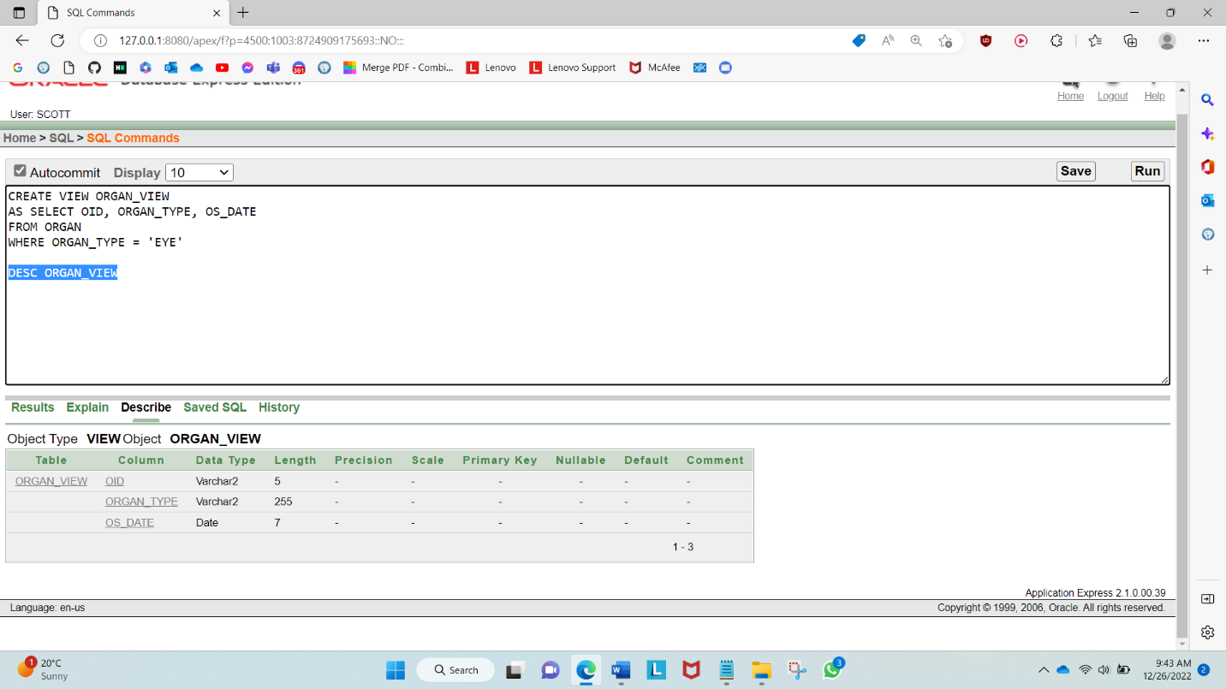

**CONCLUSION**

Our Database project is about Organ Bank Management System. While doing this project we had learnt many things. When we were doing ER Diagram, we faced some difficulties in arranging everything. Then comes normalization. It was a big challenge for us because there are too many rows. After completing normalization, we created our all tables. Then while inserting values we faced some difficulties with foreign keys. Also, we used Oracle 10G and it wasn't supporting multiple lines, so we had to insert every line manually. Then Query part and it was fun. Overall, we had many new experiences while doing this project. Solving every problem felt like a great achievement for us. After finishing this project, we have a clearer concept in Databases.

*THANK YOU*